|  |  |  |
| --- | --- | --- |
| **Lyng Primary School P.E Knowledge Organiser** | | |
| **Topic: DODGEBALL** | Year 2 | Spring 2 |

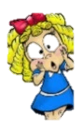



**Enquiry Questions**

* Can we perform underarm throw successfully?
* Can we perform an overarm technique with accuracy from distance?
* Can you catch a block a ball that’s thrown with power by using another ball?
* Do we understand what tactics mean?
* How do we get someone out in dodgeball?
* Can we show an understanding in a game situation?

|  |  |
| --- | --- |
| **Key words** | |
| **Spelling** | **Definition** |
| Dodge | Trying to avoid the ball being thrown at you. |
| Tactics | Use of different methods to try and get the opposition out, i.e. 3 people throwing at the same time targeting one person. |
| Backline | The area on the court where you cannot leave & at the start of the game when retrieving the balls you must return to, to begin play. |
| Block | Using another ball to prevent a ball that’s thrown at you. |
| Zone | The area of which you play the game. |
| Headshot | When a ball strikes an opponent in the head. (headshots not allowed). |

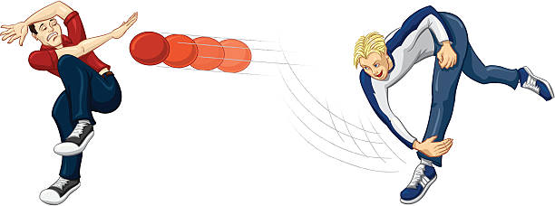

***“Dodge, Duck, Dip & Dive Dodge”***

**– Mav Levy**

|  |  |  |
| --- | --- | --- |
| **Lyng Primary School P.E Knowledge Organiser** | | |
| **Topic: DODGEBALL** | Year 2 | Spring 2 |

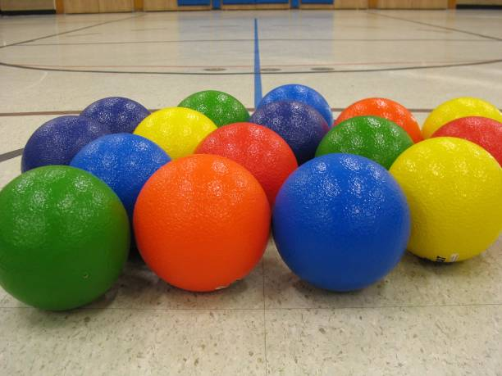

Learning Outcomes

* To throw underarm with accuracy.
* To be to continuously throw using the overarm technique with accuracy.
* To be able to identify when to block.
* To be able to identify tactics to use to get the opposition out.
* To understand methods of how to get the opposition out.
* To play a game situation with an understanding.